Structures 2 Lab

Mesh

|  |  |  |  |  |  |
| --- | --- | --- | --- | --- | --- |
| m | NOE | NON | von-Mises Stress (MPa) | Max Principal Stress (MPa) | Min Principal Stress (MPa) |
| 5.0 | 51 | 192 | 57.681 | 51.973 | -58.408 |
| 2.5 | 190 | 639 | 58.689 | 52.963 | -59.076 |
| 1.0 | 1162 | 3655 | 60.011 | 53.558 | -60.163 |
| 0.5 | 4615 | 14172 | 60.425 | 53.729 | -60.563 |
| 0.2 | 28745 | 87038 | 60.565 | 537.734 | -60.574 |
|  |  |  |  |  |  |

Use mesh size 0.5

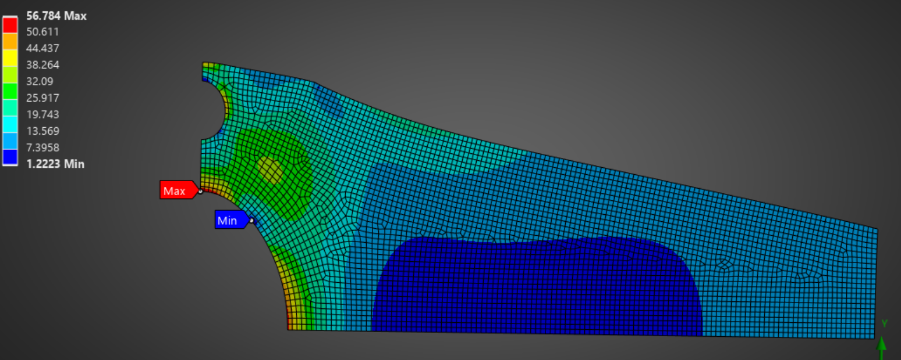

Max von-mises stress : 60.425*1.12 = 67.676

Max x - deformation: 0.45734* 1.8 = 0.823212

Max y – deformation: 0.53106*1.8 = 0.955908

